1.
Write an SQL query to display all products from a 'products' table and sort them by price in ascending order, similar to how Flipkart lists items from lowest to highest price.
SELECT * FROM products
ORDER BY price ASC;
2.
Modify your previous query to show the top 5 most expensive products using ORDER BY with DESC and LIMIT.
SELECT * FROM products
ORDER BY price DESC
LIMIT 5;

3.
Given a 'movies' table with columns 'title', 'release_year', and 'rating', write an SQL query to list all movies sorted first by release_year in descending order (latest first), then by rating in descending order (highest rated first). CREATE TABLE movies (
title VARCHAR(255),
release_year INT,
rating DECIMAL(3, 1)
);
INSERT INTO movies (title, release_year, rating)
VALUES
('The Shawshank Redemption', 1994, 9.3),
('The Godfather', 1972, 9.2),
('The Dark Knight', 2008, 9.0),
('Pulp Fiction', 1994, 8.9),
('Inception', 2010, 8.8);

SELECT title, release_year, rating FROM movies
ORDER BY release_year DESC, rating DESC;
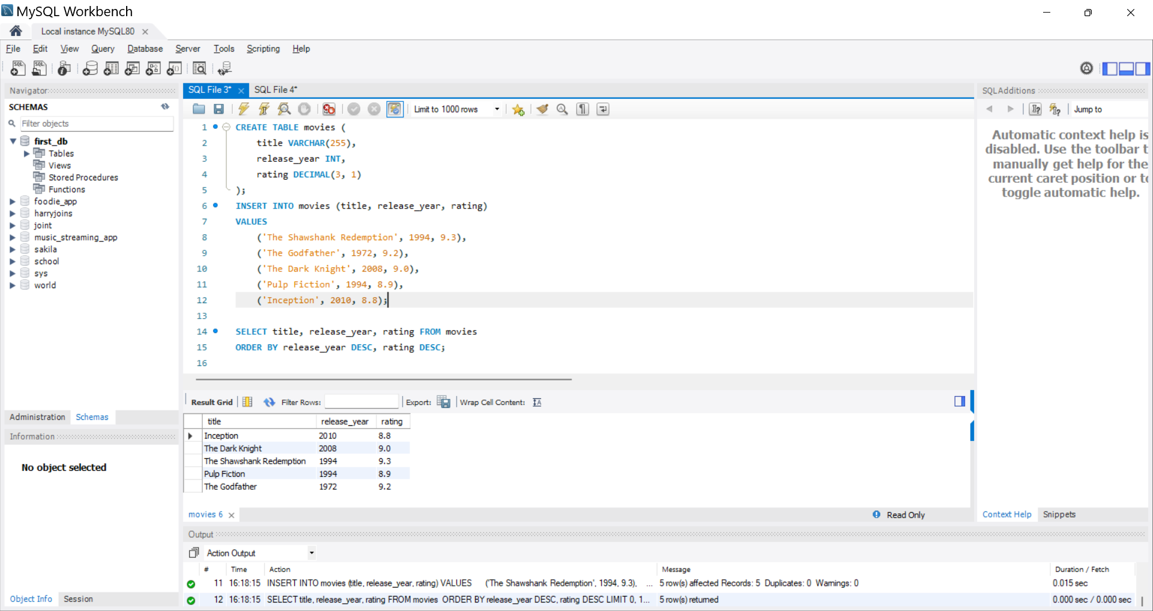

4.
Write an SQL query to display the first 10 restaurants from a 'restaurants' table, sorted alphabetically by name, just like Zomato's A-Z listing.<br><br><em><strong>Hint:</strong> Use ORDER BY with LIMIT.</em>
CREATE TABLE restaurant (
id INT PRIMARY KEY,
name VARCHAR(255) NOT NULL,
cuisine VARCHAR(100),
rating DECIMAL(3, 1)
);
INSERT INTO restaurant (id, name, cuisine, rating)
VALUES
(1, 'Zomato Bistro', 'Continental', 4.5),
(2, 'Alpha Dining', 'American', 4.2),
(3, 'Bella Italia', 'Italian', 4.8),
(4, 'Spice Route', 'Indian', 4.6),
(5, 'Dragon Wok', 'Chinese', 4.1),
(6, 'Taco Fiesta', 'Mexican', 4.3),
(7, 'Sushi Master', 'Japanese', 4.9),
(8, 'Burger Joint', 'Fast Food', 4.0),
(9, 'Vegan Delights', 'Vegan', 4.7),
(10, 'Oasis Grill', 'Mediterranean', 4.4),
(11, 'Curry House', 'Indian', 4.5),
(12, 'El Toro', 'Mexican', 4.2);

SELECT * FROM restaurant
ORDER BY name ASC
LIMIT 10;
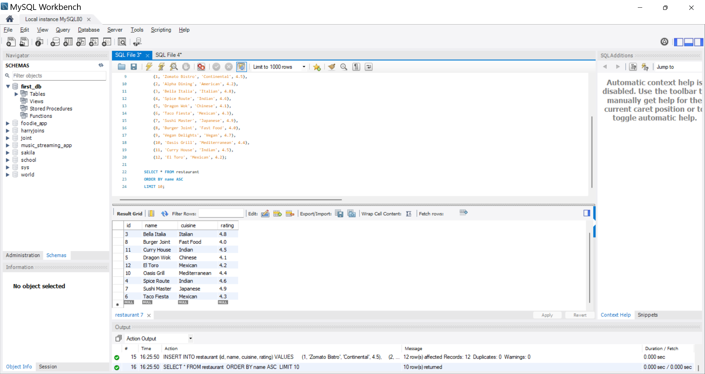
5.
Suppose you want to display the top 3 trending songs from a 'songs' table based on play_count, but if two songs have the same play_count, the more recently added song should come first. Write the SQL query to achieve this.<br><br><em><strong>Hint:</strong> Use ORDER BY with multiple columns.</em>

SELECT * FROM songs
ORDER BY play_count DESC, date_added DESC
LIMIT 3;

